Tuesday (02 March)
LIFT
A1 Bench Press (Sets: 3, Reps: 5-3)
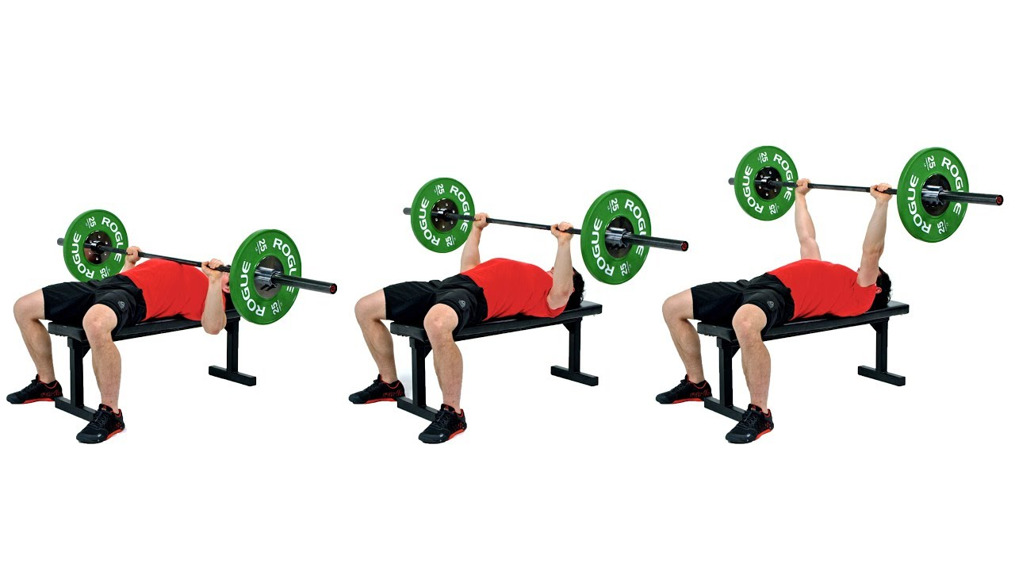
youtube.com
The Bench Press
- Lie face up on a bench. Place your hands in a comfortable position on the bar.
- Take the weight and bring it slightly forward so it sits over your chest.
- Lower the bar under control down towards your chest.
- As the bar touches your chest lift back up to the top position.
- keep your bum, back and head in contact with the bench at all times.
A2 FFE DB Split Squat (Sets: 3, Reps: 6 E/S, Rest: 90s)
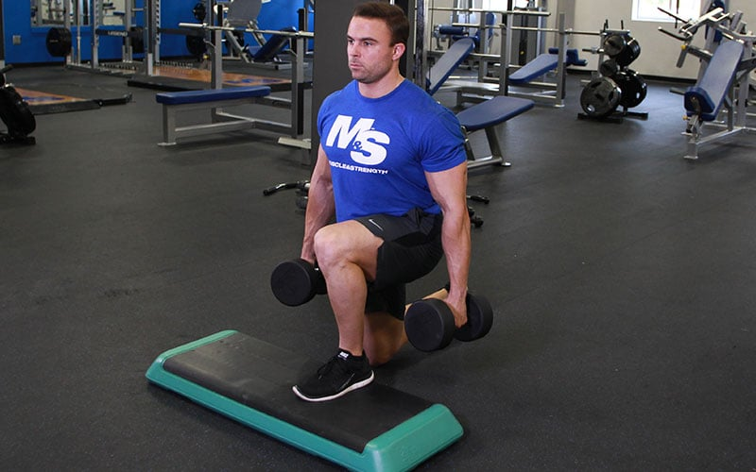
muscleandstrength.com
Front Foot Elevated Dumbbell Split Squat
- Elevate front foot on a platform, hold dumbbells at sides.
- Lower back knee toward ground, then push up through front foot.
STRONG
B1 Pendlay Row (Sets: 3, Reps: 8)
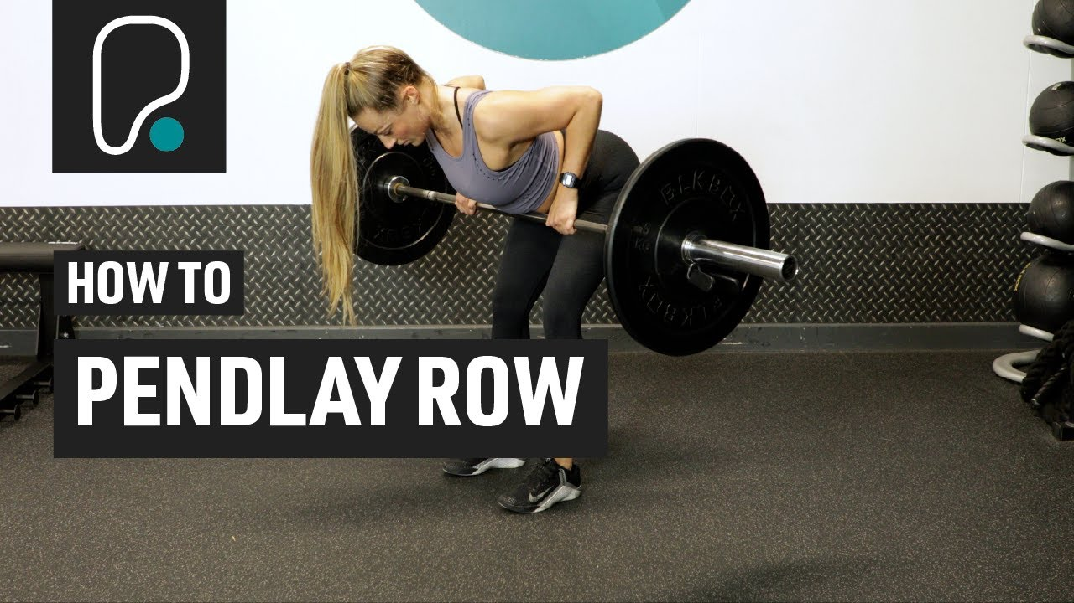
youtube.com
How To Do A Pendlay Row
- Stand with barbell on floor, hinge at hips with flat back.
- Pull bar to lower chest explosively, then lower to floor each rep.
B2 Star side Plank (Sets: 3, Reps: 20s E/S)
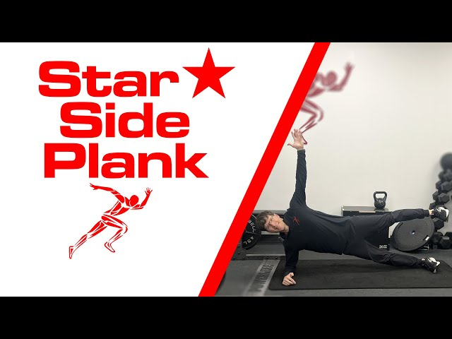
youtube.com
Star Side Plank - YouTube
- From side plank position, lift top arm and leg upward forming a star shape.
- Hold the position, engaging core.
B3 Goblet Squat (Sets: 3, Reps: 8, Rest: 60s)
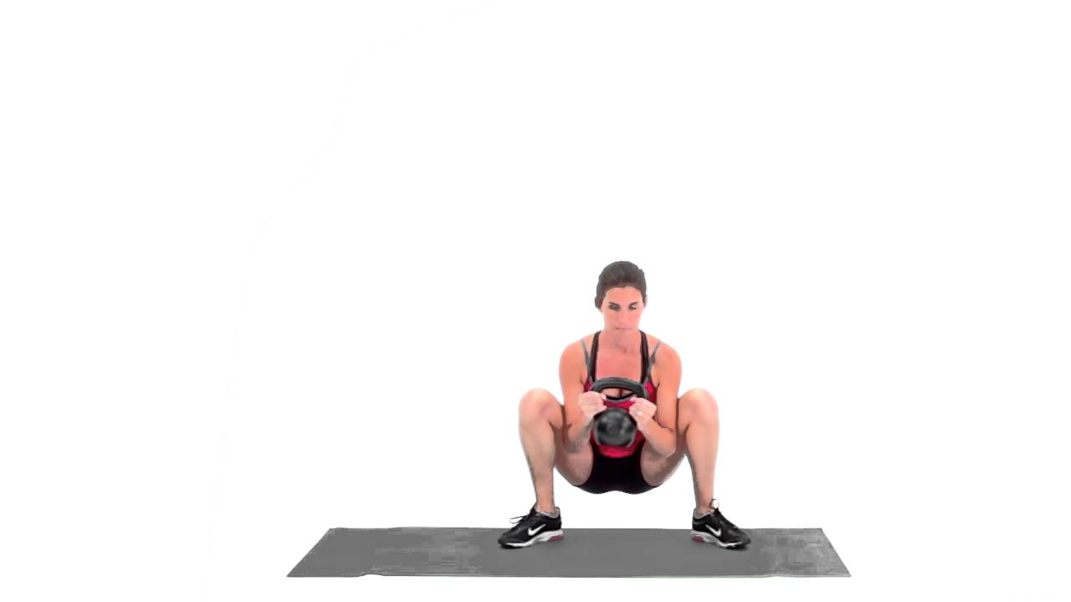
youtube.com
Goblet Squat - YouTube
- Hold dumbbell at chest, feet wider than shoulders.
- Squat down keeping chest up, then stand back up.
UPPER
C1 face pull (Sets: 3, Reps: 8, Time: 12 mins, Tempo: AMRAP)
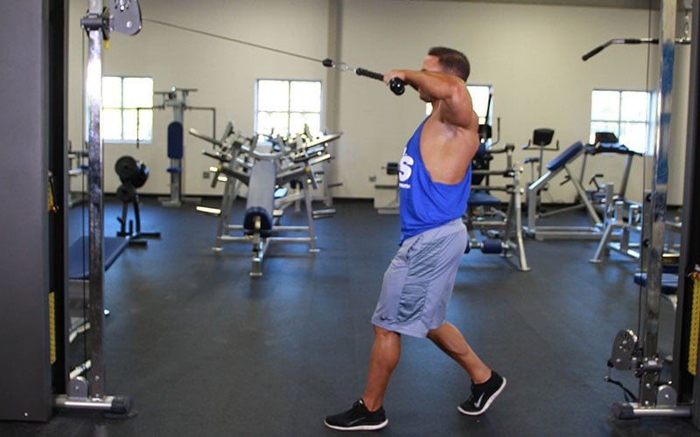
muscleandstrength.com
Cable Face Pull
- Attach rope to high pulley, pull toward face squeezing shoulder blades.
- Keep elbows high, control the return.
C2 Standing Dumbbell Bicep Curl - Pronated Grip (Sets: 3, Reps: 8, Time: 12 mins, Tempo: AMRAP)
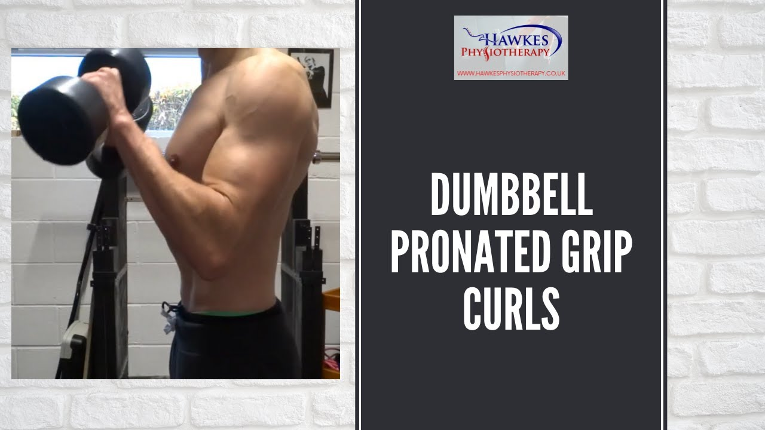
youtube.com
Dumbbell pronated grip curls: Technique video
- Stand with feet hip width apart. Take a dumbbell in each hand and turn them so that your palms face your body.
- Start with elbows straight and your wrists firm.
- Keeping your wrists straight, bend at your elbows until your forearms are in contact with the bulge in your biceps. Don't allow your elbows to come forward in the movement.
- Lower under control back down to the straight arm position.
LOWER
D1 Monster Walk with Mini-band (Reps: 2L, Time: 12 Mins, Tempo: AMRAP)
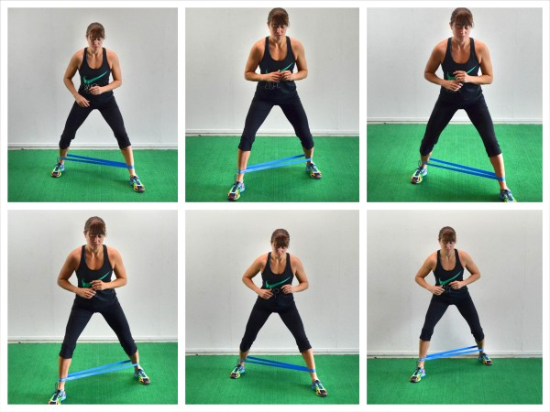
redefiningstrength.com
Mini Band Monster Walks | Redefining Strength
- Place a mini-band around your ankles or shins.
- Crouch down a little to bend at your hips and knees.
- Step forward and out to the side with one foot. Then step forward and out to the side with the other.
- Continue this movement to walk forward like a "Monster".
- Keep your torso and hips facing forward throughout the movement.
D2 HIP THRUST HOLD (Time: 12 Mins, Tempo: AMRAP)
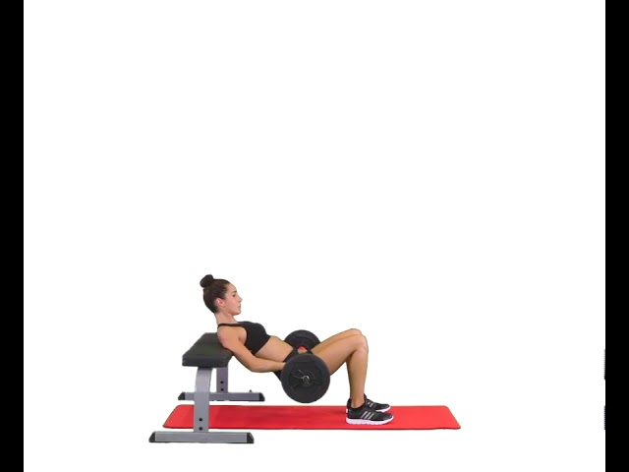
youtube.com
Hip Thrust
- Sit on floor with back against bench, barbell over hips.
- Drive hips up to hold at top position, squeezing glutes.
Thursday (04 March)
LIFT
A1 Back Squat (Sets: 3, Reps: 5-3)
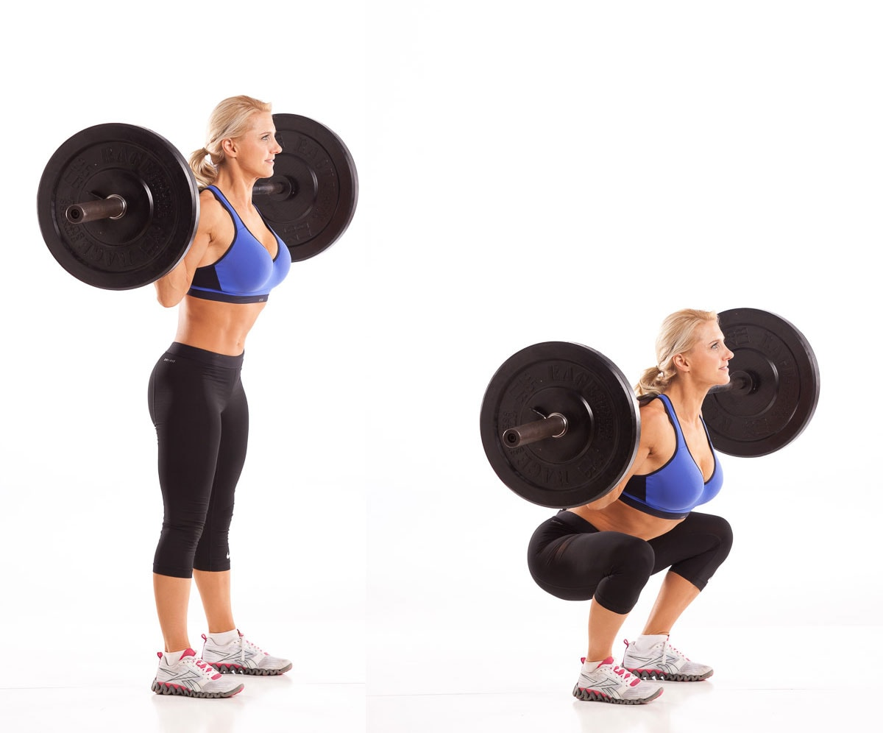
julielohre.com
How to Barbell Back Squat | Science Backed Exercise Video, Tips & FAQs
- Stand with your feet parallel and a comfortable distance apart with your weight evenly distributed between both legs.
- Take a barbell on your back, resting it evenly across your shoulders on the cushioned part of your upper back.
- Hold the bar with both hands keeping your elbows directly below your wrists.
- Keeping your chest up, bend at your knees then hips to lower your bum down towards the ground behind you.
- Go as low as you can with control, ideally your hips should go below your knees. Keeping your heels on the ground, push up into the start position.
A2 Gorilla Row (Sets: 3, Reps: 6 E/S, Rest: 90s)
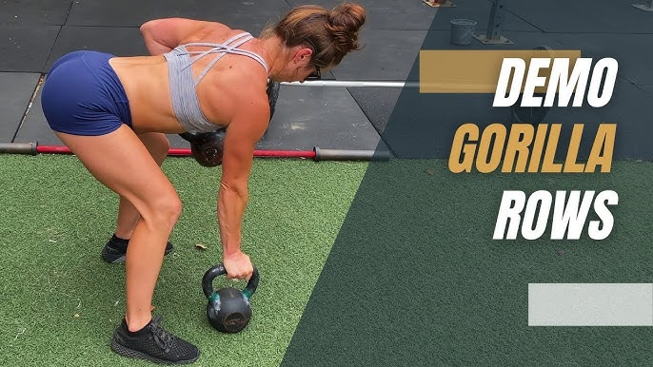
youtube.com
Gorilla Rows Movement Demo | How to do Gorilla Rows - YouTube
- Stand with kettlebells on floor, hinge at hips.
- Row one kettlebell at a time alternating sides.
STRONG
B1 Rack Pulls (Sets: 3, Reps: 10)
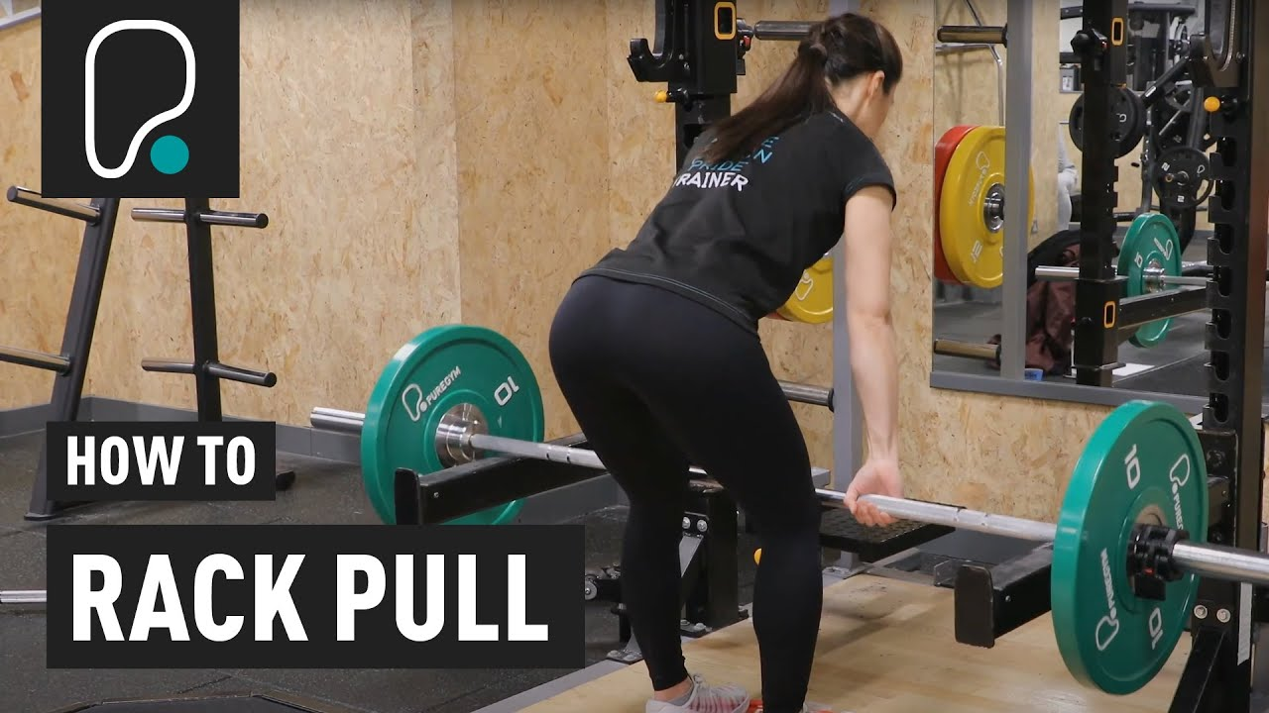
youtube.com
How To Do A Rack Pull
- Set barbell in rack at knee height, grip and lift by extending hips.
- Lower back to rack.
B2 ALT FLAT DB PRESS (Sets: 3, Reps: 6-8 E/S, Rest: 60s)
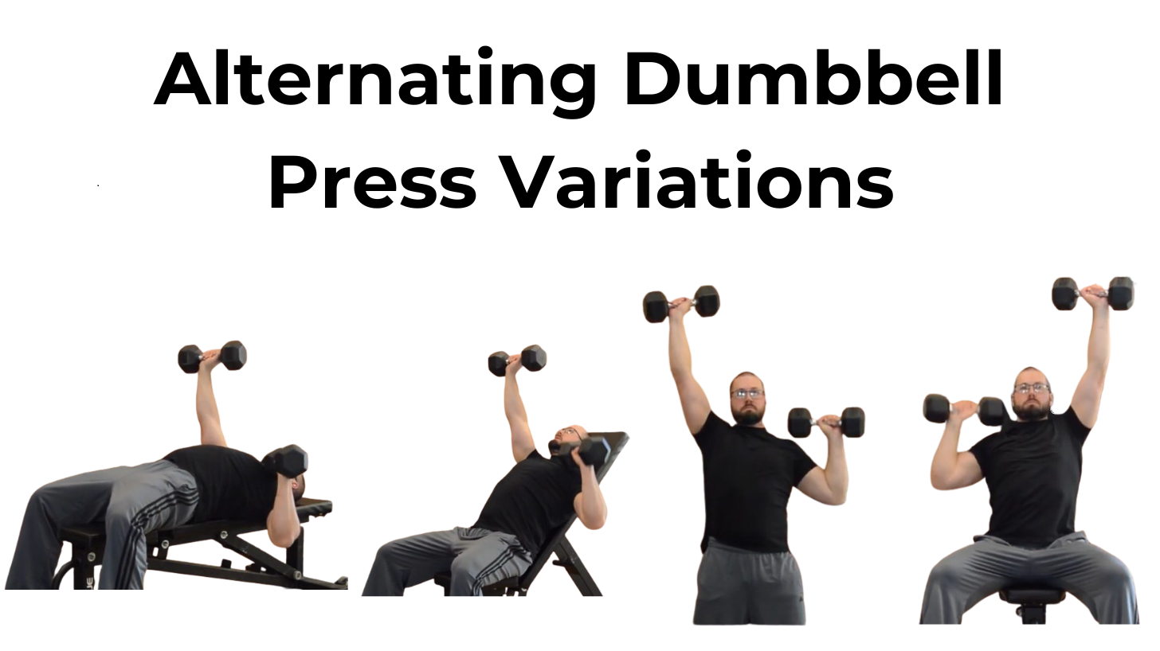
craftsbury.com
Move of the Month: Alternating Dumbbell Presses — Craftsbury ...
- Lie on flat bench, hold dumbbells above chest.
- Lower and press one arm at a time, alternating.
UPPER
C1 Hammer Floor Press (Sets: 3, Reps: 10)
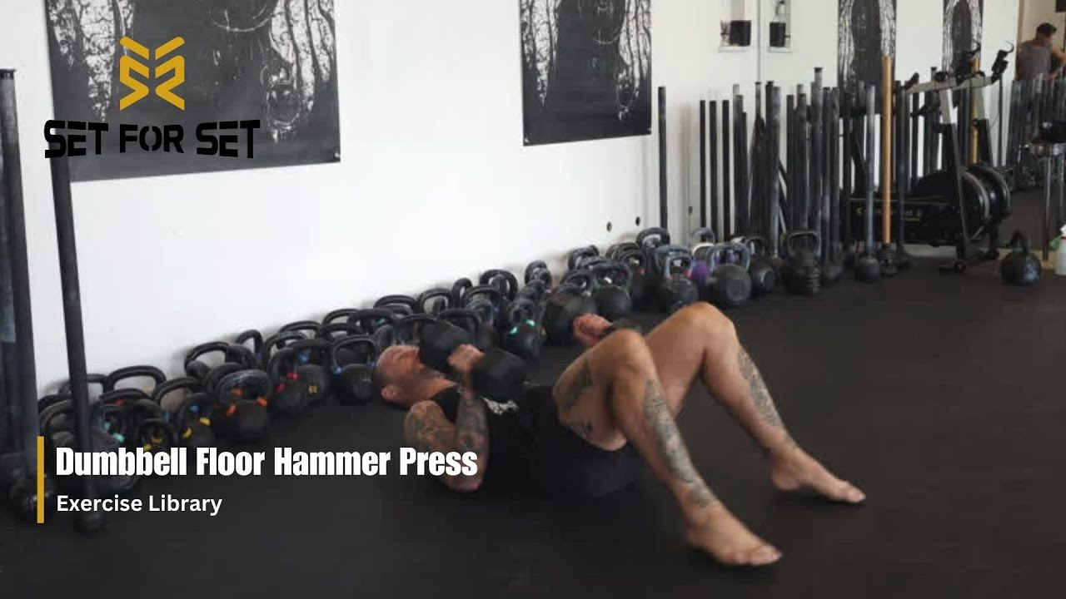
youtube.com
Dumbbell Floor Hammer Press | SFS Exercise Library
- Lie on floor, hold dumbbells with neutral grip above chest.
- Lower to sides, then press up.
C2 Single Dumbbell Overhead Triceps Extension (Sets: 3, Reps: 10, Rest: 60s)
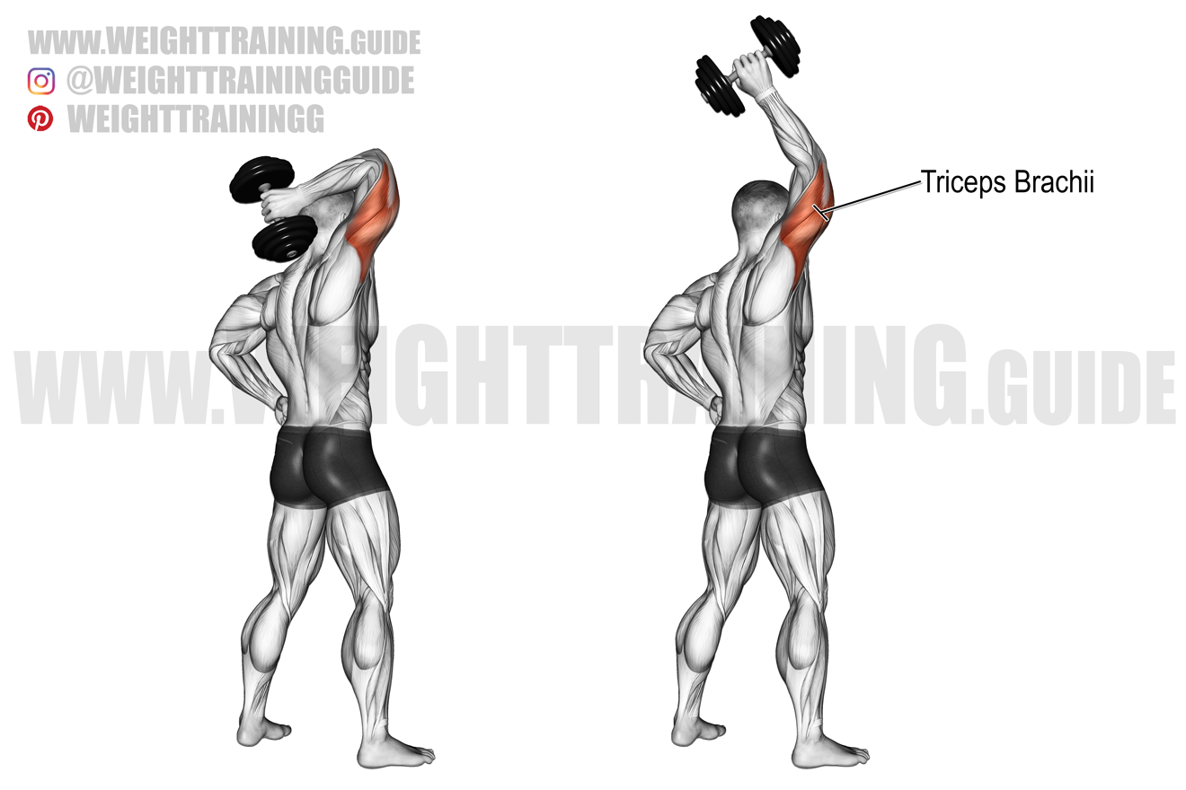
weighttraining.guide
Standing one-arm overhead dumbbell triceps extension exercise
- Stand with feet hip width apart, chest out, chin up and tummy gently drawn in.
- Take hold of a dumbbell in both hands.
- Start with elbows bent overhead and hands behind your back.
- Straighten your elbows to bring the dumbbell straight up above your head.
- Bend your elbow to return under control to the start position.
LOWER
D1 Barbell Calf Raise on Floor (Sets: 3, Reps: 8)
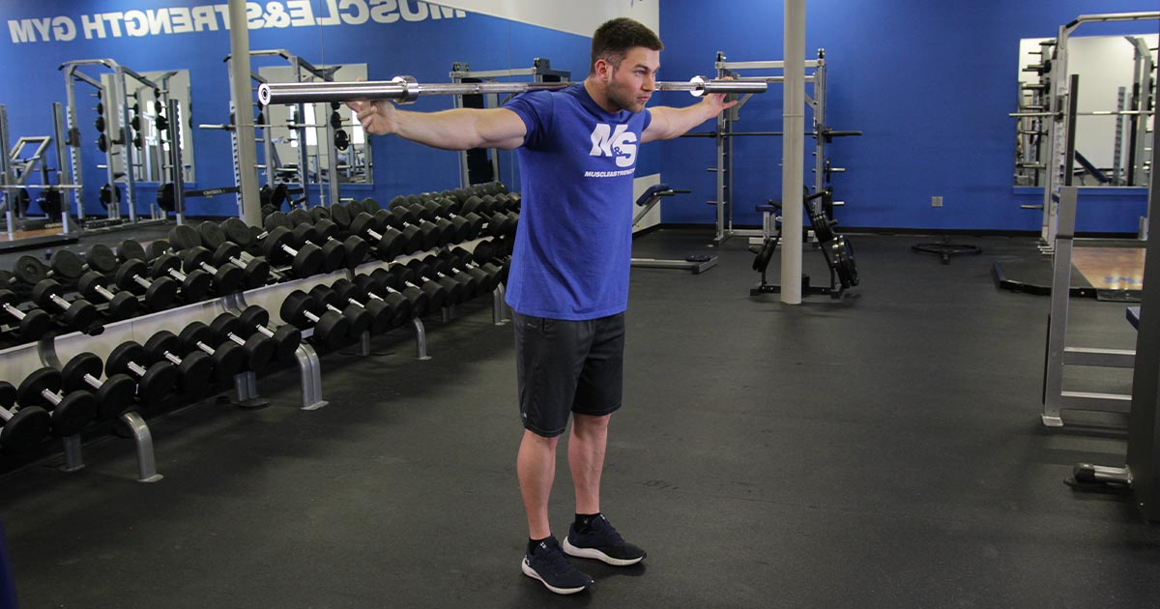
muscleandstrength.com
Standing Barbell Calf Raise (On Floor)
- Stand with your feet hip width apart.
- To add resistance put a barbell on your back, resting it evenly across your shoulders on the cushioned part of your upper back.
- Keep your chest up and tummy drawn in with 30% effort.
- Working both legs at the same time come right up on your toes as high as you can.
- From the top position lower until your heels are just off the ground and then raise back up again.
D2 Bulgarian Split Squat with Dumbbells (Sets: 3, Reps: 8 E/S, Rest: 60s)
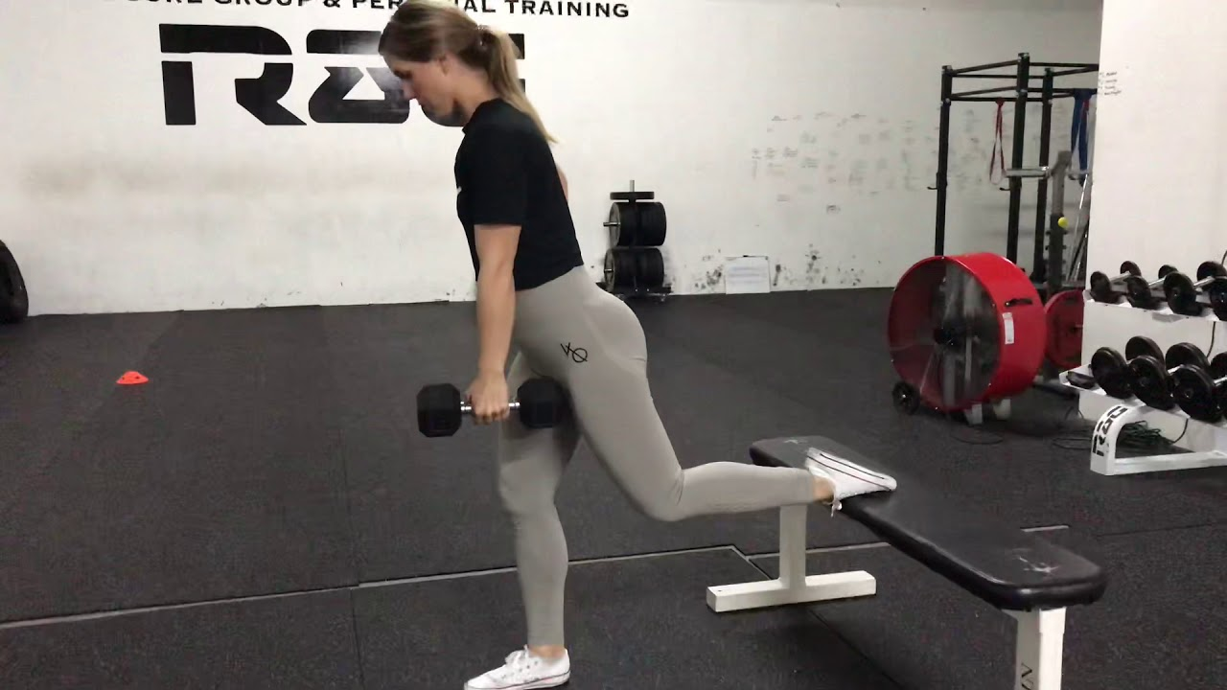
youtube.com
Weighted Dumbbell Bulgarian Split Squat
- Hold a dumbbell in each hand with your arms fully extended at your sides and your palms facing each other.
- With your feet hip-width apart, place your rear foot on a bench behind you.
- Your feet should be a large stride length apart.
- Lower your hips toward the floor so that your rear knee comes close to the floor.
- Pause and drive through your front heel to return to the starting position.
Saturday (06 March)
LIFT
A1 Clean Grip Deadlift (Sets: 3, Reps: 5-3)
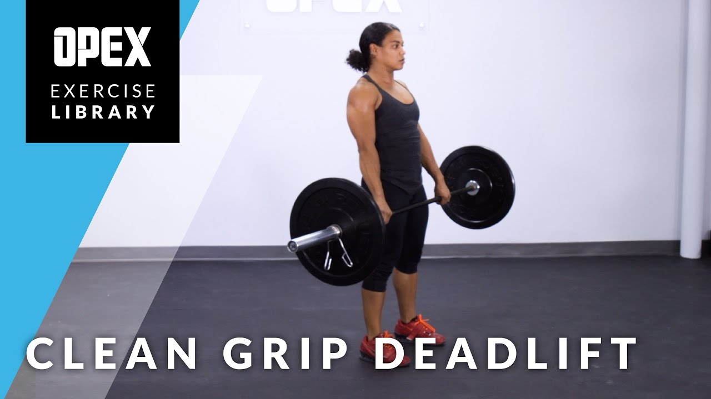
youtube.com
Clean Grip Deadlift - OPEX Exercise Library
- Start standing with your toes under the bar.
- Lean over, bend your knees and take hold of the bar with your hands a little wider than your knees and palms facing you.
- Push your chest out and hollow your lower back. Gently draw in your tummy with approximately 30% effort.
- Pushing through your feet and keeping your low back hollowed with your chest pushed out, lift the bar until you are standing in an upright position.
- Keeping your low back hollowed with your chest pushed out; lower the bar in a controlled manner down to the floor.
A2 Seated Dumbbell Shoulder Press - Pronated Grip (Sets: 3, Reps: 6, Rest: 90s)
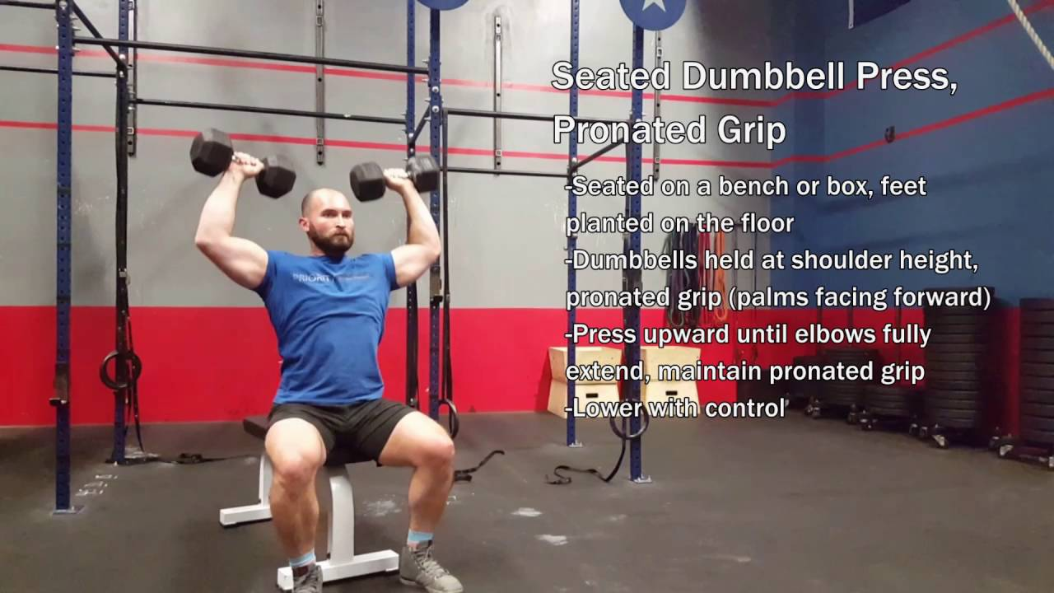
youtube.com
Seated Dumbbell Press, Pronated Grip
- Sit with your back supported on the rest. Lift the dumbbells to shoulder height with your palms facing forward.
- Without arching your back push up above your shoulders to a straight arm position.
- Lower under control to the start position.
STRONG
B1 Barbell Lunge (Sets: 3, Reps: 8 E/S)
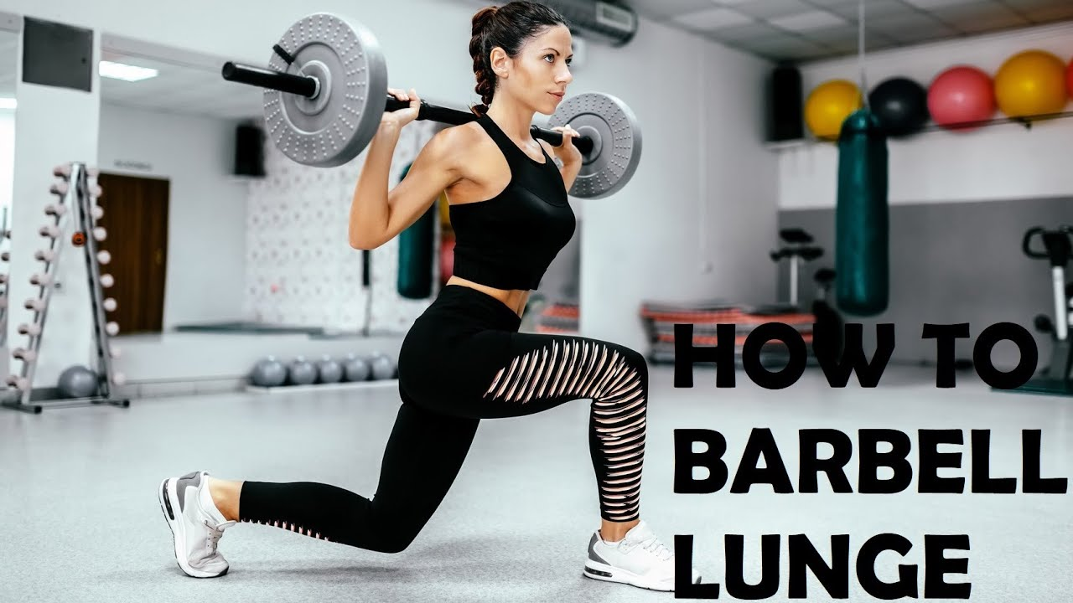
youtube.com
How to BARBELL LUNGE | FORWARD LUNGE Leg Exercise | Barbell Lunges FOR BEGINNERS
- Take a barbell on your back, resting it evenly across your shoulders on the cushioned part of your upper back.
- Hold the bar with both hands keeping your elbows directly below your wrists.
- Push your chest up and draw in your tummy with 30% effort. Step forward approximately 1½ times natural stride length.
- Putting your weight on your front leg lower yourself straight down keeping your front knee behind your toes.
- Coming down there should be approximately a 90 degree angle at the back of both knees. Your back heel should come off the ground.
- From the bottom position push back up with your weight coming through your front foot. Your front foot should come back to the start position of the exercise.
- Keep your head and chest upright with your hips level and forward facing during the whole movement.
B2 Supinated DB bent over row (Sets: 3, Reps: 8, Rest: 60s)
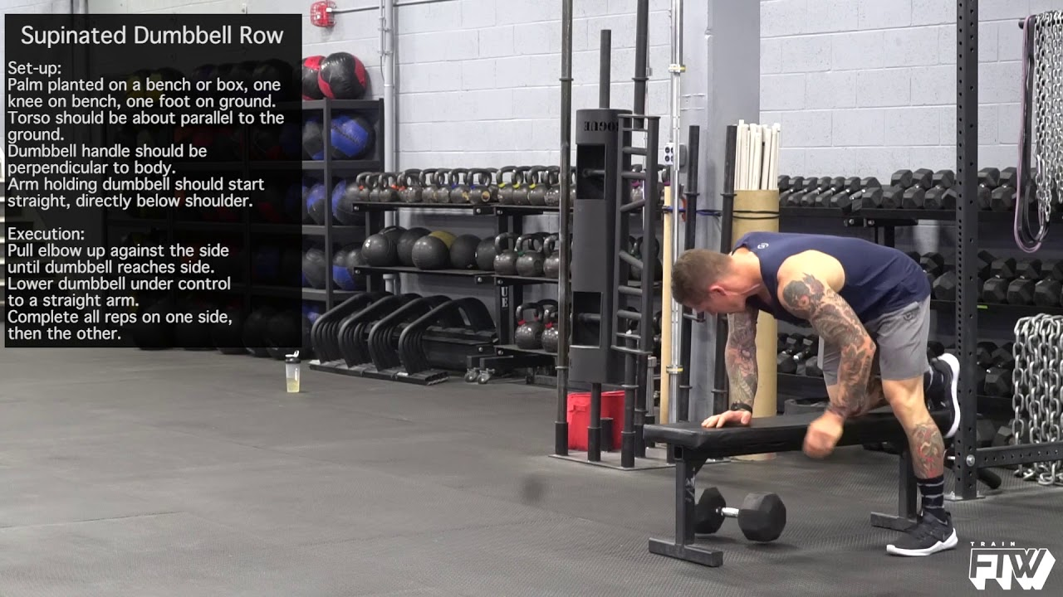
youtube.com
Supinated Dumbbell Row
- Bend over holding dumbbells with palms facing forward.
- Row dumbbells to sides, squeezing shoulder blades.
UPPER
C1 DB Cuban press (Sets: 3, Reps: 40s)
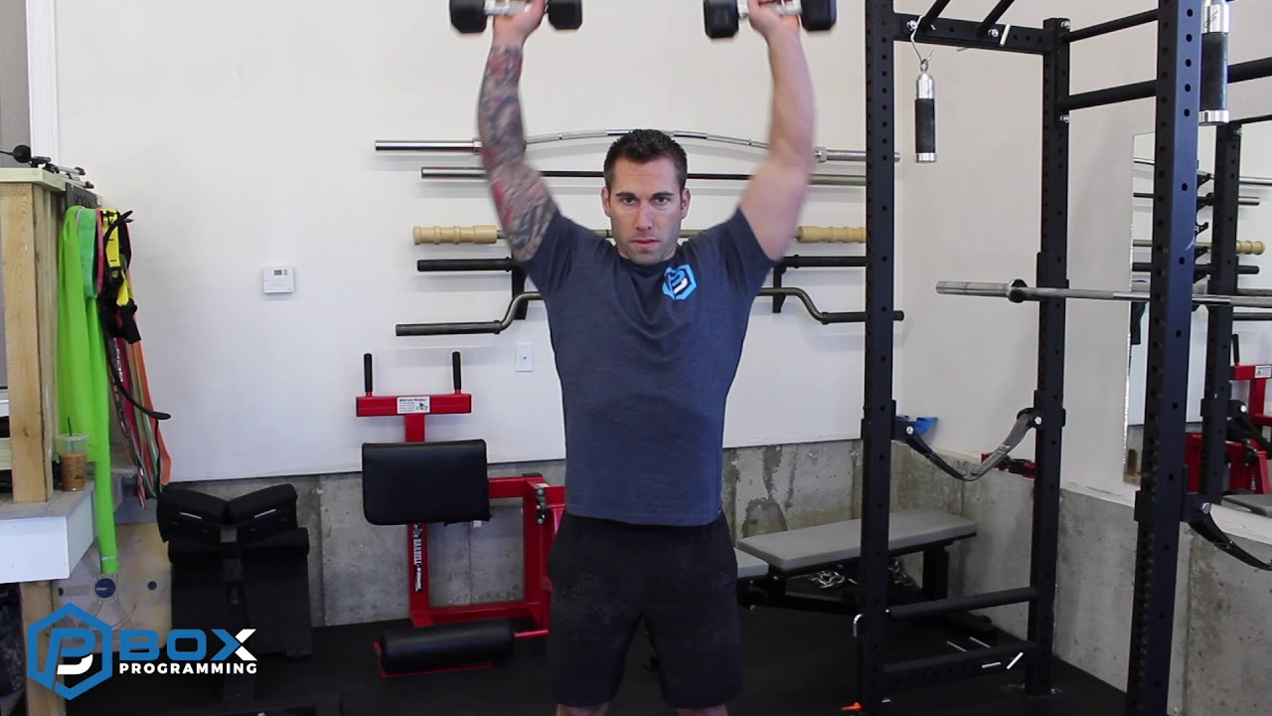
youtube.com
Dumbbell Cuban Press
- Hold dumbbells, perform upright row to external rotation, then overhead press.
- Lower in reverse.
C2 Landmine Twists (Sets: 3, Reps: 2L)
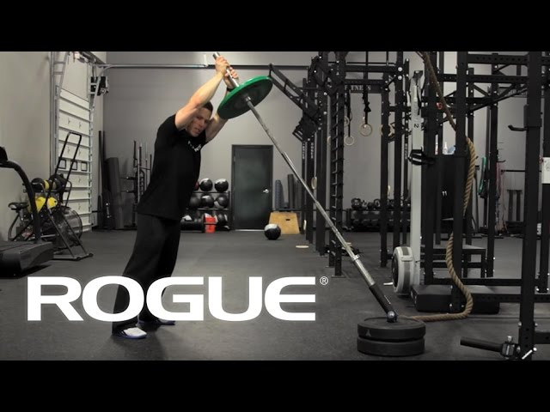
youtube.com
Movement Demo - The Landmine Twist
- Anchor barbell in landmine, hold end with both hands.
- Twist torso side to side pivoting feet.
LOWER
D1 Prowler Push (Sets: 3, Reps: 1-2L)
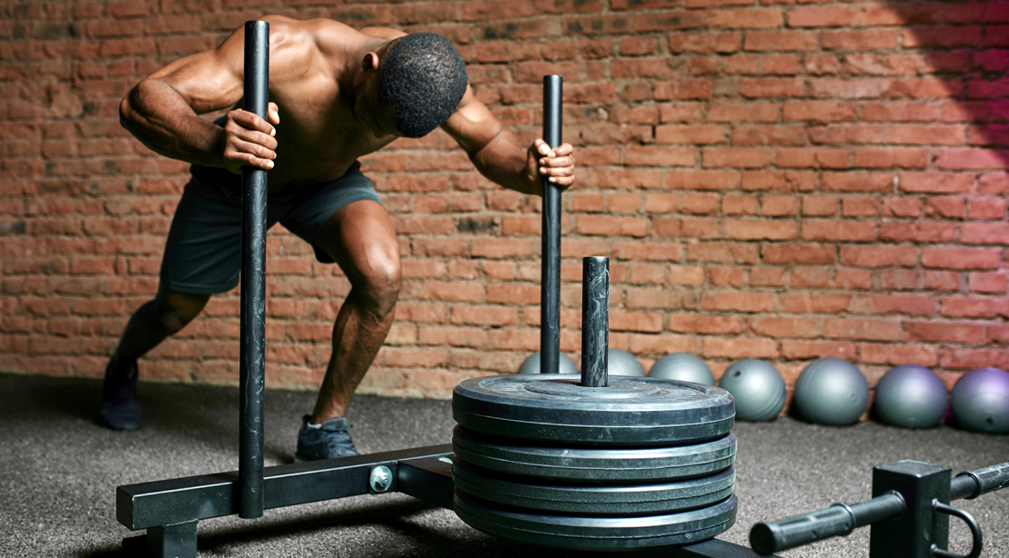
muscleandfitness.com
Gym Gimmicks: The Prowler - Muscle & Fitness
- Firmly grip the prowler or sled. Some prefer to hold higher up, others slightly lower.
- Set your feet up so they are the same width as your running stance. When you stride, make sure that your feet remain the same width apart the entire time.
- It is important that you drive through your forefoot, and make sure that all of your toes remain in contact with the ground.
- Keep your arms locked after initiating the push, don't let them act as shock absorbers.
- Make sure that your body remains in proper alignment from the head to feet.
- Shoes with more aggressive tread can allow for better leverage when pushing off and may allow you to push more load
- Use the entire stride of each leg to get the most out of each push
D2 Sprinter Bridge (Sets: 3, Reps: 30-40s, Rest: 60s)
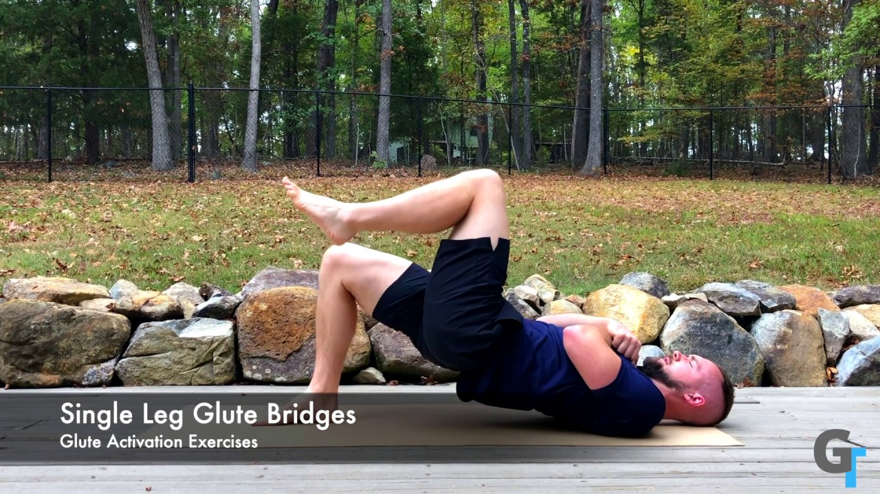
youtube.com
Single Leg Hip Bridge - Exercise Demonstration
- Lie on back, one knee bent with foot flat, other leg extended.
- Lift hips high, squeeze glute of bent leg.

